**Documentation to Run the predictions file**

**Step 1: open the cloud lab and login with your credentials. After login you will be able to see all nodes if available.**

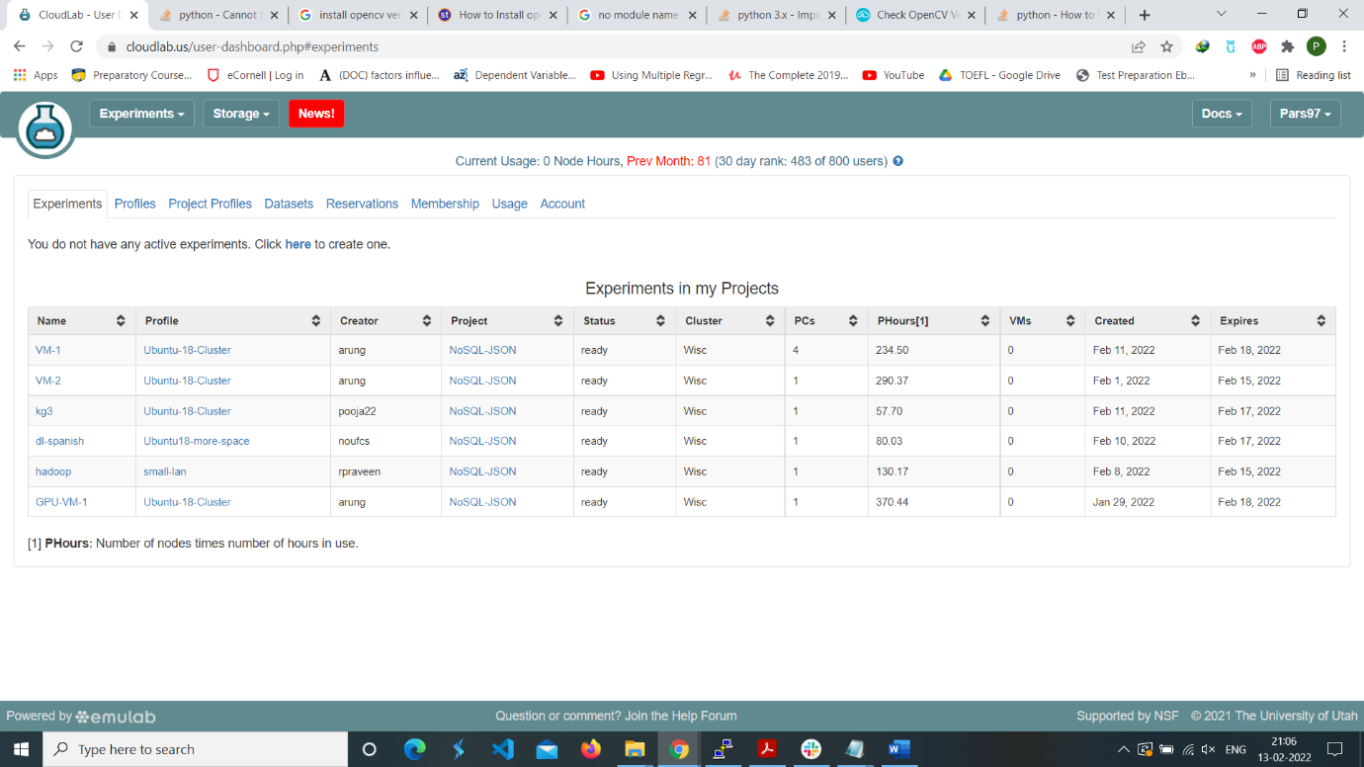

**Step 2: if node is not available create node or use existing node after that this will be displayed.**

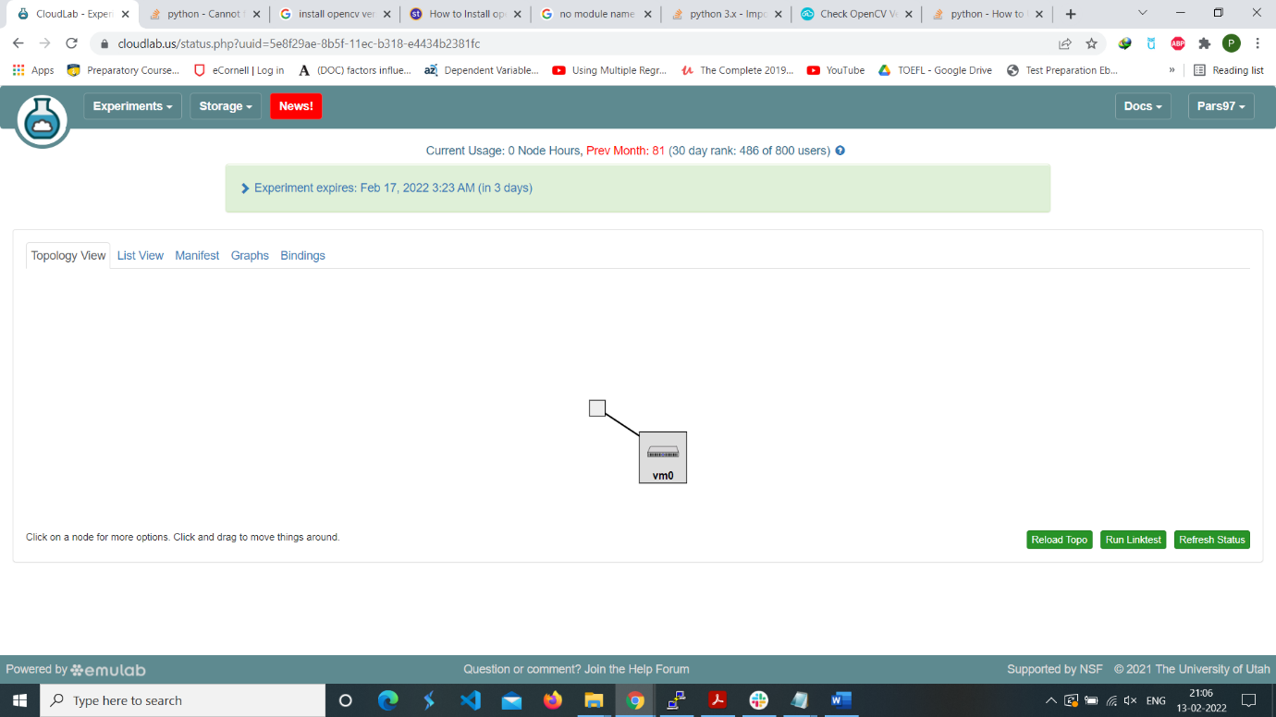

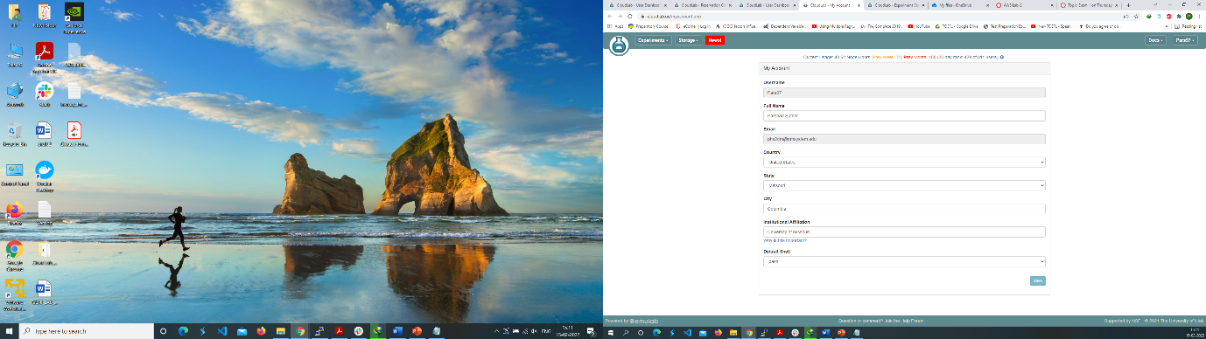

**Change default shell to bash**

**Using putty to start working on cloud lab**

**Step 3: click on the list view on top left of the cloud lab copy the address the one highlighted in green arrow.**

**Step 4: open your putty window and click on the session and paste the above ssh address which you have taken from cloudlab list view.**

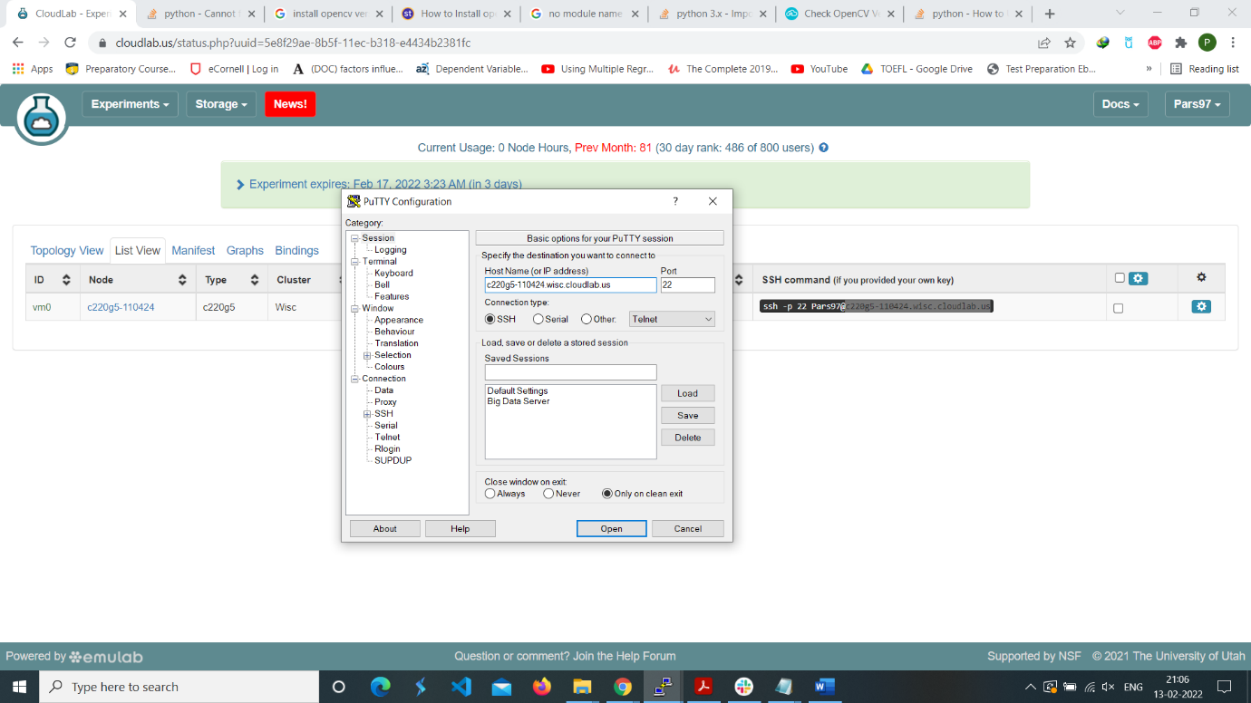

**Step 5: Navigate to SSh 🡪 Auth and add the private key to get access of cloud lab server. Click open**

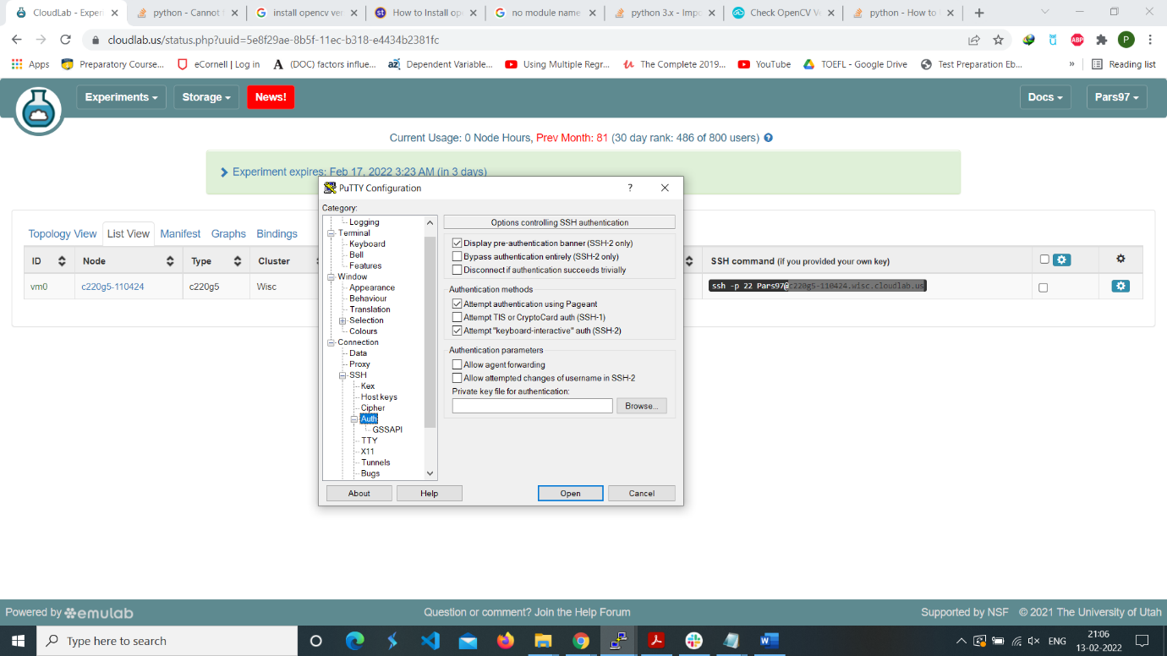

**Step 6: To access the current node we are working on the node we created**

**Step 7: Navigate into the directory in which we are having data and create directory exp**

**cd /mydata**

**mkdir exp**

**cd exp**

**Step 8: Cloning the git repo for using the data**

**git clone** [**https://github.com/UMKC BigDataLab/DeepLearningSpanishAmerican.git**](https://github.com/UMKC%20BigDataLab/DeepLearningSpanishAmerican.git)

**Step 9: Creating a new conda environment with python version 3.7.3**

**conda create -n <name of environment> python=3.7.3**which is here test7 you can give any name you want.

**Step 10: Activating conda environment after this you will be able to see your env name at left most of cmd**

**conda activate test7**

**Step 11: Installing different packages**

**pip3 install tensorflow==2.4.3 or pip3 install tensorflow==2.6.2**

**pip3 install pandas**

**pip3 install matplotlib**

**pip3 install scipy**

**pip3 install sklearn**

**pip3 install rdflib**

**pip3 install imutils**

**pip3 install keras-ocr**

**pip3 install openpyxl**

**Step 12: Installing opencv with version 4.5.4.60**

**pip3 install --upgrade opencv-python==4.5.4.60**

**Step 13: Running the predictions file with the arguments passed**

**python3 predictions.py -i RandomSamples/OG-Images/ -o RandomSamples/cleaned-Images/ -j RandomSamples/JSON/Keras/ -m ../Model/keras-recognizer_custom.h5**

Note: pass the path as per your system.

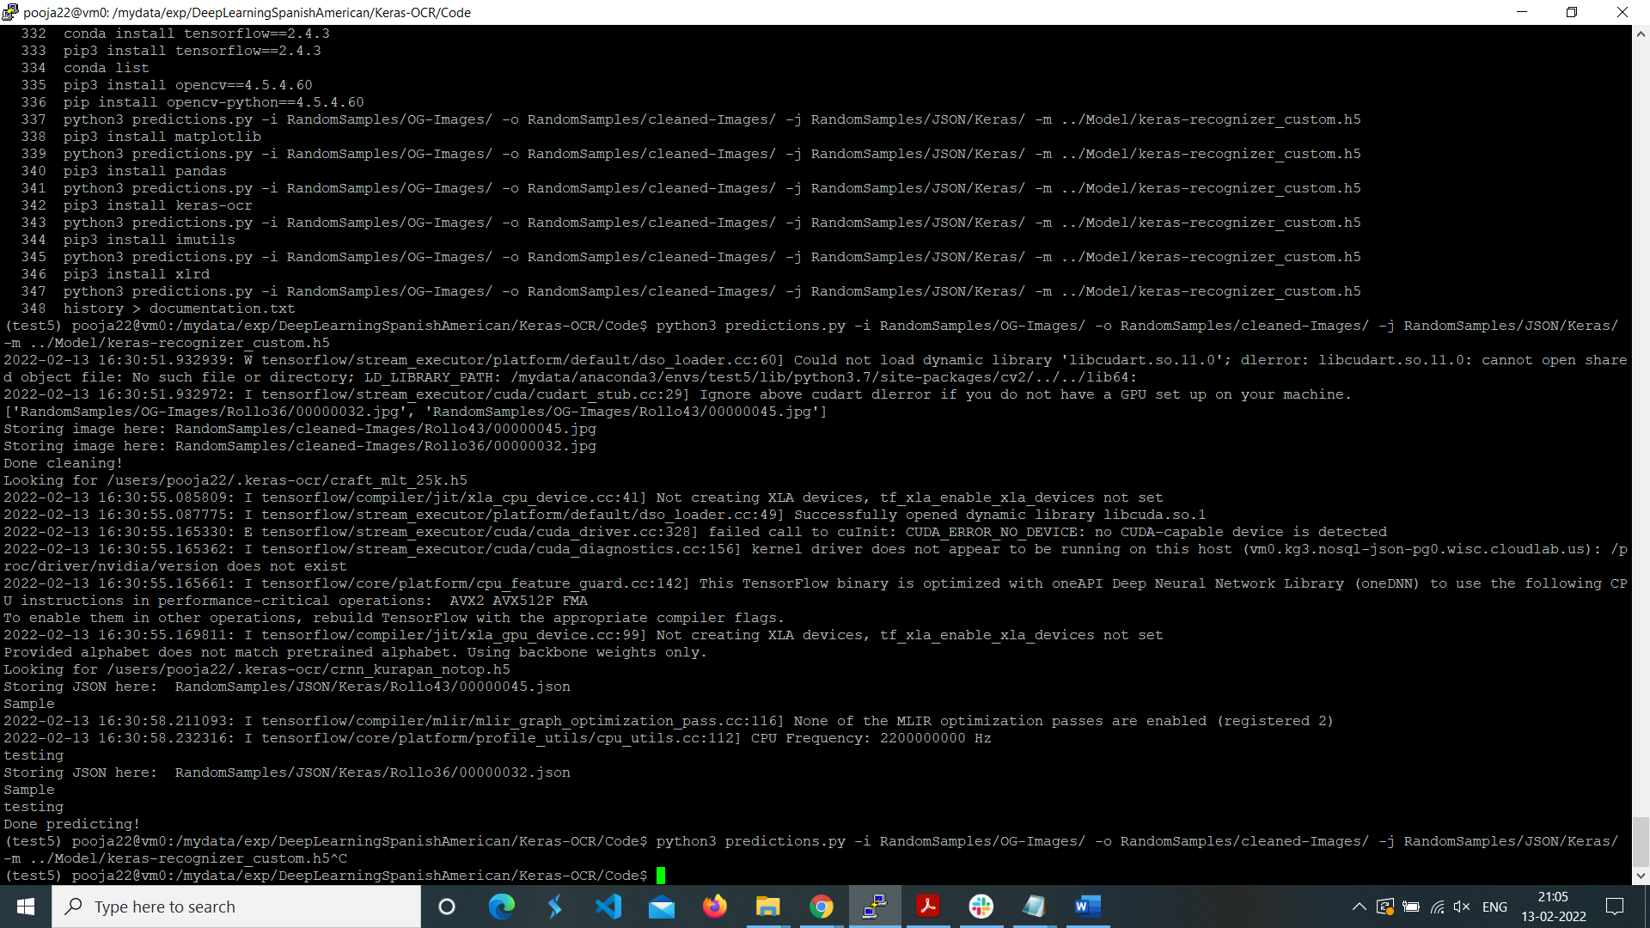

**Now you can check if your file is running correctly or not.**

**For the Full Text Indexing :**

**Step:1 We need to add**

com.bigdata.rdf.store.AbstractTripleStore.textIndex=true

in the RWStore.properties

**Step:-2 We need to add things in the update query**

So basically, we need to add the path of the turtle file to further query it.

Like for example:

/D:/bigdataproject/TTL/Escribanias-rollo-70-words-2022-02-16.ttl

After we are done with adding the path into the update, we make sure we have chosen File Path or URL in type section.

After this step we need to add query to try test the Full Text indexing so in this case we are trying to test here is :

PREFIX bds: <http://www.bigdata.com/rdf/search#>

SELECT ?subj ?label ?cosine

WHERE {

?label bds:search "m*" .

?label bds:relevance ?cosine .

?subj ?p ?label .

}

Order by ?cosine

So here we would get all the results starting with M and the value associated with it.